# **Template –** **FERPA Release Process**

The template named “Template – FERPA Release Process” is applicable to CampusNexus Student.

## Purpose and Outcome

This template provides a form sequence and supporting workflow for a FERPA Release form to be submitted by a student. The sequence requires the following:

* A **Student record** must exist in the CampusNexus Student database.
* The student must have a **Portal login** to log into this authenticated sequence.
* FERPA student information and FERPA groups must be configured in CampusNexus Student.

Upon completion of the sequence:

* The options selected on the FERPA form are added to the student record in Contact Manager.
* The Data Block Indicator (FERPA) is selected and the FERPA icon is displayed on the student record.

## Prerequisites

The template was built in Forms Builder using the applications listed below. The template is forward compatible with later versions of the listed applications.

|  |  |
| --- | --- |
| **Application** | **Minimum Version** |
| Forms Builder Designer and Renderer | 3.4 |
| Web Client for CampusNexus Student | 19.0 |
| Workflow Composer | 2.6 |
| Packages installed from Package Manager in Workflow Composer | Activities and Contracts (V1) 19.0.0  Activities and Contracts (V2) 19.0.0  Forms Builder Contracts 3.4 |
| Workflow Tracking Database | N/A |
| Staff STS 2.0 | 2.0 |

## Step 1: Download and Import the Template

1. Download the template file (xml) to your environment (local drive or network location).
2. Log into **Forms Builder Designer**.
3. Click the **Export/Import** tile.
4. Select the **Import** tab.
5. Click **Select exported file** and navigate to the downloaded template file (xml).
6. Click **Import**.

* [Export/Import](https://help.campusmanagement.com/FB/3.x/Content/ExportImport.htm)

### The following forms will be imported:

### FERPA Release Form

### Custom - Confirmation Standard No Auto Close

## Step 2: In Form Designer…

1. From the **Forms** slide out, select the **FERPA Release Form**.
2. Customize the form for your environment. Modify properties on current fields to make them required, etc., or add/remove fields on form.

Make sure you edit the text in the Labels and HTML controls as applicable for your institution.

Notes:

### The form has several HTML components with empty HTML properties. These components serve as placeholders for the form layout.

### The Checkbox components are bound to the workflow via the Model property.

The 2 check boxes under the heading “Directory Information to Release” are bound to:

- vm.models.myAckNot

- vm.models.myAckTrue

The 8 check boxes under the heading “Education Information to Release” are bound using an array starting at [0]:

- vm.models.mylist[0] through vm.models.mylist[7]

### The array in the Model value assumes that the data in the FERPA tables starts at index value 1 and that there are no gaps between the stored values. You may need to adjust the values to match the FERPA configuration in your CampusNexus Student database.

* [Fields](https://help.campusmanagement.com/FB/3.x/Content/Fields.htm) and [Components](https://help.campusmanagement.com/FB/3.x/Content/Components.htm)

1. **Save** the form.

* Repeat steps 1-3 for the Custom - Confirmation Standard No Auto Close form.

## Step 3: In Sequence Designer…

1. Select the **FERPA Release Form Sequence**.

The sequence contains the following forms in this order:

### FERPA Release Form

### Custom - Confirmation Standard No Auto Close

1. Click **Save As** to create a copy of the sequence/workflow and customize the copy for your use. This way you can always refer to the original sequence/workflow you downloaded.
2. Optional - Add a custom style (theme) associated with your campus.

* [Themes](https://help.campusmanagement.com/FB/3.x/Content/Themes.htm)

1. Select your sequence in the Sequences pane.
2. In the Properties Pane:
   * Ensure that the **Authentication Product** is **Student**.

* Select the **End State Form** named “Custom - Confirmation Standard No Auto Close”.

1. **Save** the sequence**.**
2. Open the associated sequence workflow.

* [Open the Workflow for a Sequence](https://help.campusmanagement.com/FB/3.x/Content/HostedEnv.htm)

## Step 4: In Workflow Composer…

1. Double-click the **Submit** transition and locate the **Save Relationship Addr** sequence.

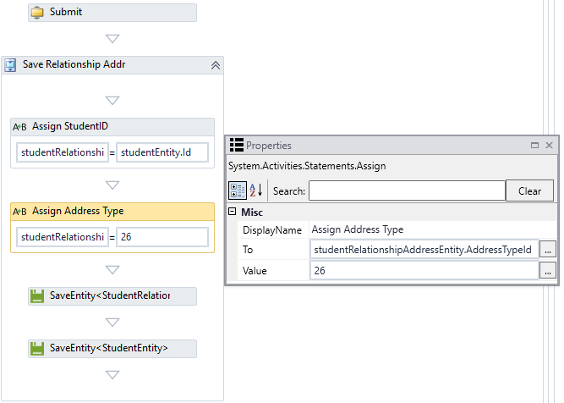

Modify the hard-coded **Address Type** value of “26” as appropriate. The address type value should be the FERPA Address Type value for your environment. To get the value, you may either query the database directly or use the LookupReferenceItem activity within the workflow.

Simply drop the **LookupReferenceItem** activity into the workflow and select the following values:

Reference Item Type = Address Type

Reference Item = FERPA Address Type

The activity will return the Id value.

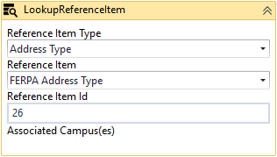

1. Scroll down to the **Create Directory Info** sequence and expand the **DoWhile** activity.

Ensure that the **count** value matches the number of items listed in the “Directory Information to Release” section of the form and the number of fields in the **cmferpadirfields** database table.

In our example there are 16 directory Ids in the table. We are going to loop through and add each one as selected/unselected for the student relationship table.

Note that the count starts at 0. If the list of items in the “Directory Information to Release” section contains 16 items, the Condition of the DoWhile activity needs to be set to “count<15”.

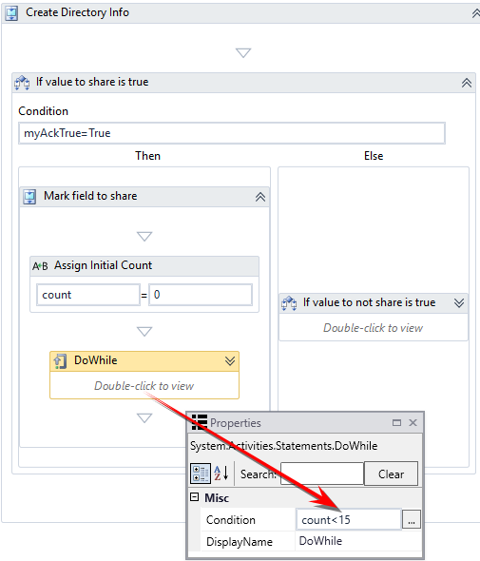

Also ensure that the **Assign Id** activity within the DoWhile loop matches the actual Id from the cmferpadirfields table.

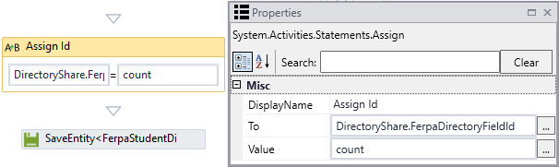

If the Ids are not sequential in the database, add an ExecuteQuery activity to look up the exact Id value.

* [ExecuteQuery activity](https://help.campusmanagement.com/WF/Content/Workflow/ExecuteQuery.htm?Highlight=ExecuteQuery)

1. Scroll further down to the **Academic Info to Share** sequence and check the **count** value in the **Condition** field of the **DoWhile** activity.

Ensure that the count value matches the number of items listed in the “Education Information to Release” section of the form and the number of fields in the **cmferpaacademicfields** table.

In our example, there are 8 directory Id's in the table. We are going to loop through and add each one as selected/unselected based on the selection on the form.

Note that the count starts at 0. If the list of items in the “Education Information to Release” section contains 8 items, the Condition of the DoWhile activity needs to be set to “count<7”.

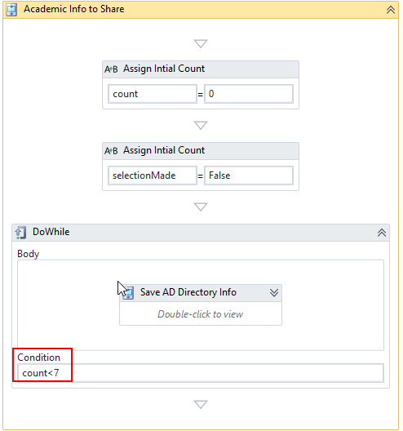

Also ensure that the **Assign Id** activity within the DoWhile loop matches the actual Id from the cmferpaacademicfields table.

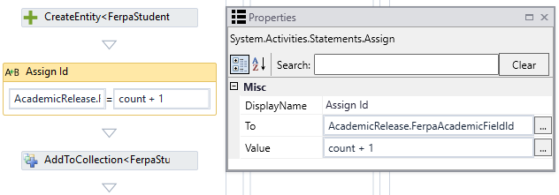

If the Ids are not sequential in the database, add an ExecuteQuery activity to look up the exact Id value.

* [ExecuteQuery activity](https://help.campusmanagement.com/WF/Content/Workflow/ExecuteQuery.htm?Highlight=ExecuteQuery)

## Step 5: In Forms Renderer and CampusNexus Student…

Select your sequence and try it out!

* [Sequence List](https://help.campusmanagement.com/FB/3.x/Content/SequenceList.htm)

1. Find your **FERPA Release Form Sequence** and copy the **URL** to the clipboard.
2. Log in to Portal as a **student** and complete the form sequence.
3. In CampusNexus Student:
   * Verify that the options selected on the FERPA form are added to the student record in Contact Manager.
   * Verify the Data Block Indicator (FERPA) is selected and the FERPA icon is displayed on the student record.

## Step 6: Lastly…

Once your updated sequence has been tested successfully, it is recommended that you disable the workflow for the original Template version.

1. In Workflow Composer, in the Server section of the ribbon, click **Open**.
2. Find the workflow named “**FERPA Release Form Sequence**”.
3. Clear the **Enabled** check box and click **Save**.